BFS:
def water_jug_bfs():
visited = []
queue = [((0, 0), [])] # simple list as queue

while len(queue) > 0:
(x, y), path = queue.pop(0) # dequeue (FIFO)

if (x, y) in visited:
continue
visited.append((x, y))
path = path + [(x, y)]
# Goal condition
if x == 2:
return path
# Possible moves
next_states = [
(4, y), # Fill 4L
(x, 3), # Fill 3L
(0, y), # Empty 4L
(x, 0), # Empty 3L
(x - min(x, 3 - y), y + min(x, 3 - y)), # 4 → 3
(x + min(y, 4 - x), y - min(y, 4 - x)) # 3 → 4
]

for state in next_states:
if state not in visited:
queue.append((state, path)) # enqueue
return None
print("BFS Path:")
print(water_jug_bfs())

OUTPUT:
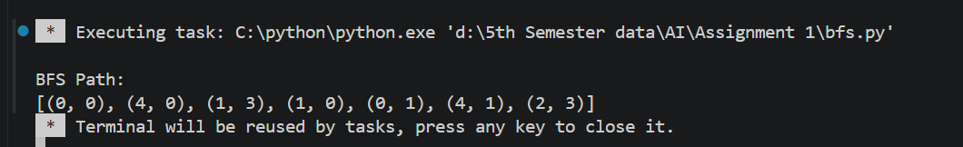

DFS
def water_jug_dfs():
visited = []
stack = [((0, 0), [])] # simple list as stack

while len(stack) > 0:
(x, y), path = stack.pop() # pop (LIFO)

if (x, y) in visited:
continue

visited.append((x, y))
path = path + [(x, y)]
# Goal condition
if x == 2:
return path

# Possible moves
next_states = [
(4, y),
(x, 3),
(0, y),
(x, 0),
(x - min(x, 3 - y), y + min(x, 3 - y)),
(x + min(y, 4 - x), y - min(y, 4 - x))
]

for state in next_states:
if state not in visited:
stack.append((state, path)) # push
return None
print("DFS Path:")
print(water_jug_dfs())
OUTPUT:
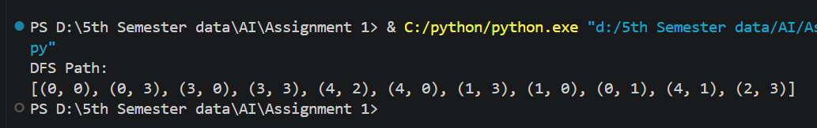
END,,,

